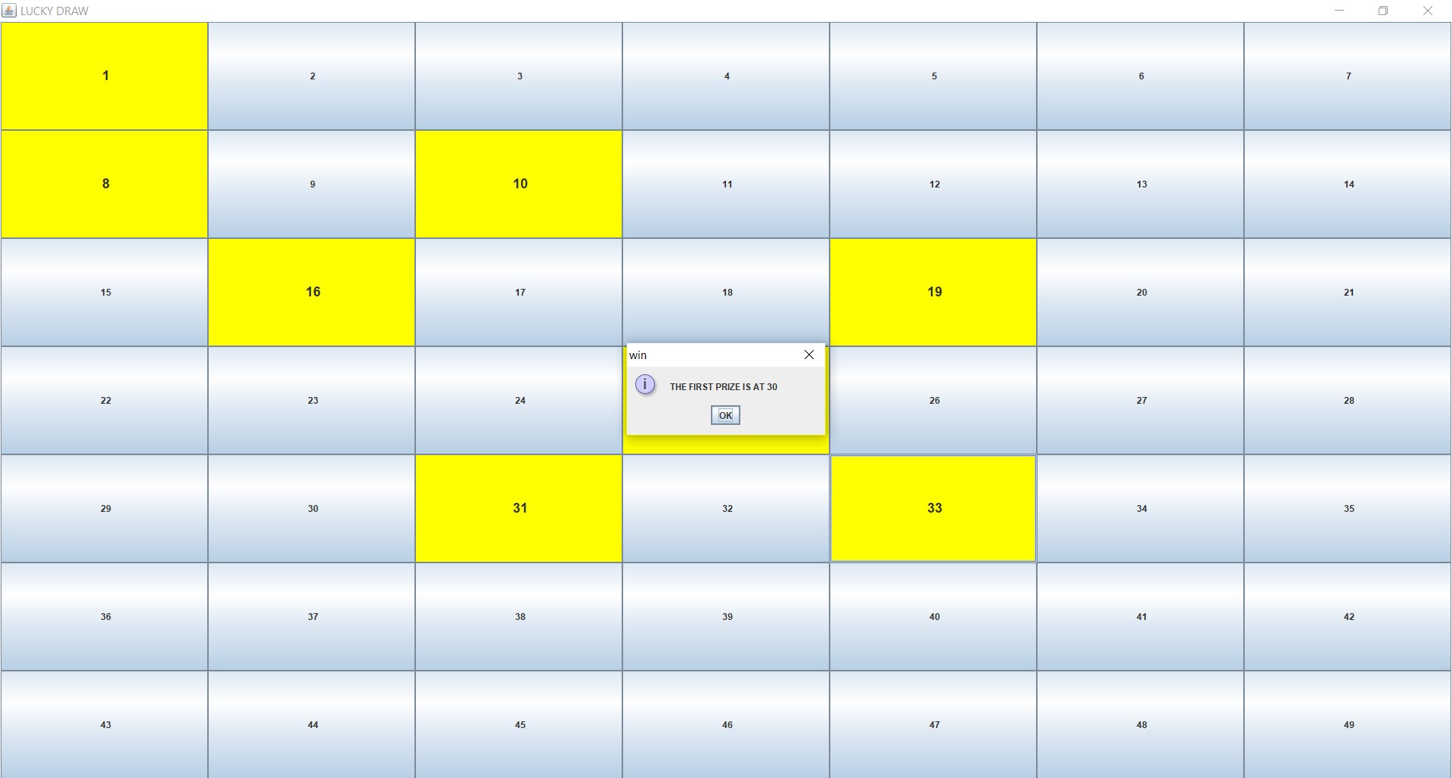

A simple GUI application, the user will have few chances to select where is the first prize.